Editorial
Time keeps rolling on and our next annual event is only just around the corner. It is planned for Sunday 18th October and will be held at the Social Club on Walsall Road as usual. We are looking forward to seeing you all there, but please tell your friends and relations about it too. There is probably someone in your circle of friends and relations who has not yet been to one of our annual events. Please invite them along. We would love to see new faces as well as our loyal supporters. Our exhibition opens at 10.30am. I look forward to seeing you there.
The same day will also feature the launch of the society’s new book “Bridgtown Bits and Bobs” written as a joint venture by John Devey and myself. It features lots of new photos not previously published. Why is it called “Bits and Bobs”? Pick up a copy on the day and read what it says on the back cover. That’s where you will find the answer to that question. The book retails at £6.00 per copy.
From time to time we get asked for copies of our first book “Bridgtown Memories” which has been sold out for some time. I am delighted to tell you that we have now obtained further copies of this book and they too will be on sale on 18th October. These are still at the original price of £5.00. If this book is missing from your collection you will now be able to put things right.
I am very grateful to members of our team who keep this magazine going by supplying me with articles, memories, photographs, etc. Occasionally we get contributions from our wider circle of friends. Many of you have worthwhile memories that others would find interesting. If you could just write a few notes about these then I would be able to turn them into an article for you. Please do that. It’s the only way that this magazine will continue to flourish. Please help us out.

David Williams (editor), 17th September 2015

3

Coffee Days

During the course of the year the society hosts several coffee days at Bethel Church in Union Street. The last one was held on 27th August. It is an opportunity for members to get together and chat. In addition there is always some interesting pictures or videos to see. As the picture below shows, sometimes these keep our audience spellbound.

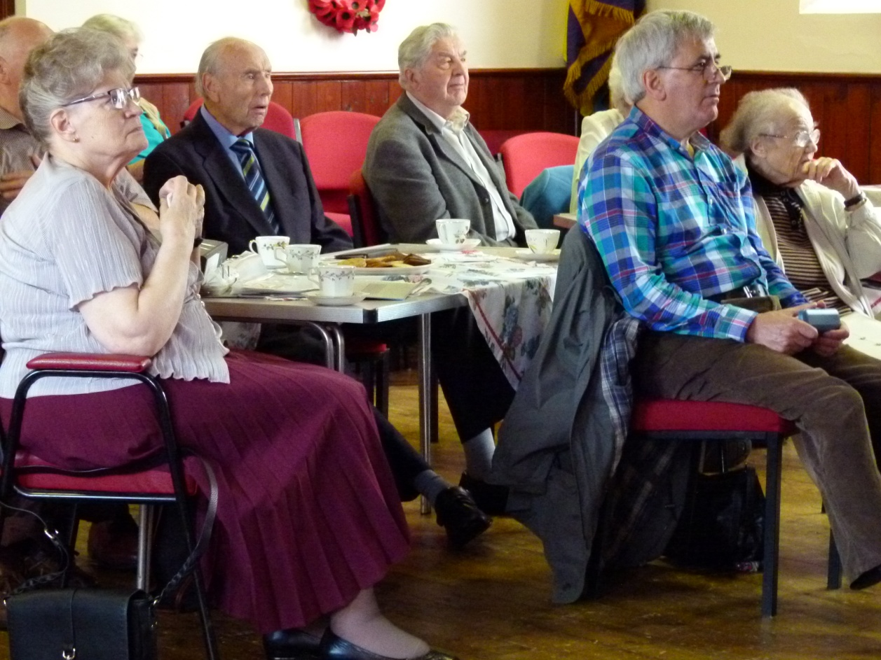

The next of these events is scheduled for Thursday 19th November between 2pm and 4pm. Why don’t you pop along and join us on that day? These events provide an excellent chance for you to bring along some photographs, press cuttings or treasured item that you could show to others.

4

BRIDGTOWN AND DISTRICT LOCAL HISTORY SOCIETY
ANNUAL EXHIBITION
“BRIDGTOWN BITS AND BOBS”

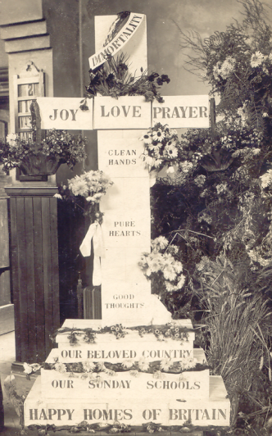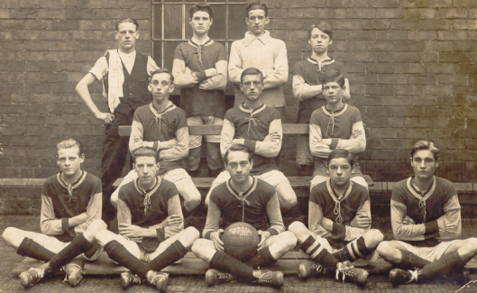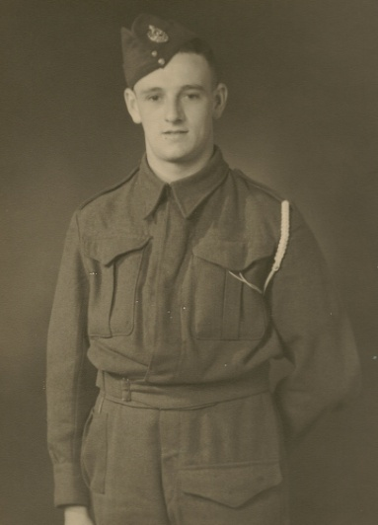

SUNDAY OCTOBER 18TH
10.30am to 4 pm.
BRIDGTOWN SOCIAL CLUB,
WALSALL RD.
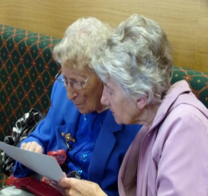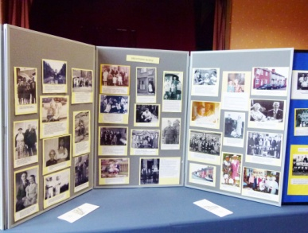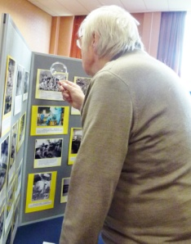

EVERYONE WELCOME. ENTRANCE FREE. REFRESHMENTS

This article has been received from Mary Beech. It will bring back memories to many other people too, I am sure. Thank you Mary. Ed.

My Time With The A.T.S. (1944 – 1947)
Mary Beech (nee Smith)
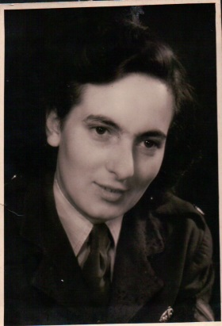
It was in February 1944 when I received my call-up papers. I was to report to Dalkeith in Scotland for a six week initial training course in the grounds of Dalkeith Abbey. We were billeted in huts sleeping about twelve girls in beds down each side of the room with a coke stove in the middle. If you were near the middle you were lucky and kept warm – the beds near the end were not so good!
Our training consisted of marching and drilling on the barrack square (Oh the blisters!), lectures and medical and dental treatment. I remember, in particular, the injections – being marched up one side of the room for a jab in one arm and down the other for a shot in the second. I cannot recall what we were injected for!
One thing we did not like was being kitted out in protective clothing, gas masks and steel helmets, and then made to sit in a room full of gas – very scary but nobody ever got gassed! After basic training I was posted to GHQ 2nd Echelon, 21st Army group in Paddington as a typist. After a few months the V1s started to come over. This was quite frightening – listening for the engine to stop then counting to seven to hear the explosion. Around this time all leave was cancelled and travel stopped due to the D-day landings. One good thing about being in London was the free theatre tickets we were given. I saw plays, opera and the ballet and once went to a variety show that was broadcast on the telly.
6
Eventually the bombing became so intensive that we were forced to sleep in the cellars of the large houses in which we were billeted. I remember waking up in the morning to cockroaches crawling all over the floor! – Soon after we were transferred to Cowley Barracks near Oxford, where it was lovely and quiet. Whilst in Oxford I celebrated my 21st birthday. A small group of us went to a pub in the city. The only problem was that we had to drink what they had got.
On May 7th 1945 we were posted overseas. We were taken by truck to a nearby airfield and loaded into a Dakota troop carrier where we were made to sit on steel lockers down each side of the plane. There were no windows that I can recall. Moreover we did not know that the war was nearly over and so feared attack by German fighters. It was not a comfortable flight. After a short while we landed safely in Brussels, much to our delight – we did not even know where we were going! What a difference Brussels was. We were billeted in a large block of flats – four to a room and with bathrooms! – What a luxury.
I have very fond memories of Brussels. Our very first day was, of course, V-E Day and there was great rejoicing and dancing in the streets. After that we were very well provided for, with good forces clubs and dance halls. I loved to go out dancing. One particular memory was taking the tram to Waterloo and looking down on the battlefield.
Sadly, after eighteen months we had to leave. We were posted to a grim, cold, German barracks just outside Hamburg. As we were driven in, my first impression was of a scene of utter devastation. We passed miles of houses flattened by the allied bombing, in which, I understand, there were still people living in the cellars of their former homes. This was very upsetting.
The winter of 1946/7 was very cold and we worked in a hanger-like building with no heat – forcing us to wear our overcoats and mittens for typing. One bright spot was being allowed to join the yachting club, where a charming young German man tried to teach my friend Sheila and I to sail on the Alster (a lake in the centre of the city). After about five months in Hamburg I got my demob papers and so travelled back to be greeted by the worst winter in living memory, with feet of snow everywhere.
My greatest memory is of all the good friends I made during my time in the ATS. I must admit, though, I was so glad to get back home.

7

Heritage Trail
Have you seen our new sign? It is now in place outside the Costa Coffee outlet on the island at Churchbridge. Why don’t you drive in and have a good look at it? This is the first of many such signs that we plan to have erected around our local area. We are currently working on two more. One will be in North Street and one by Longford House. It is a long job to get these things done as we have to find funding and get planning permission in every case. However, we are determined that our proud heritage will be remembered.

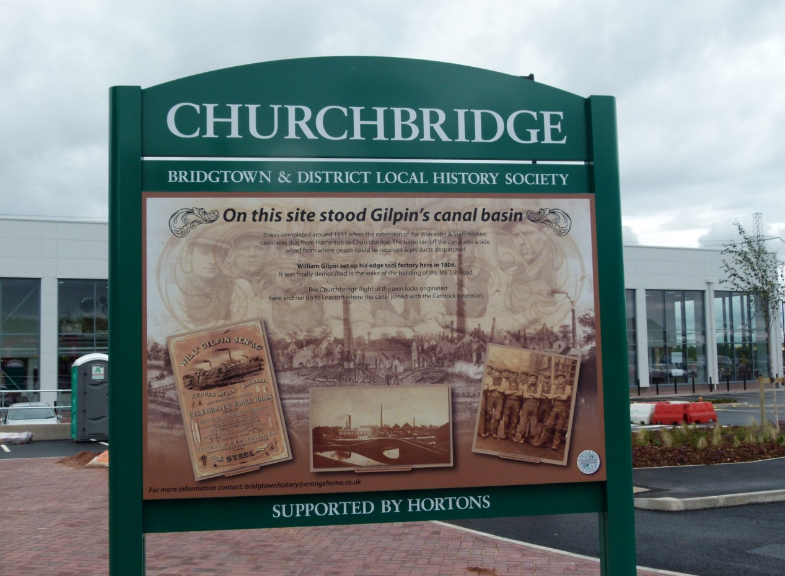

EATING IN THE UK IN THE FIFTIES
- Frozen food was called ice cream.
- Nothing ever went off in the fridge because we never had one.
- Ice cream only came in one colour and one flavour.
8
SOCIETY ARCHIVES

One of the problems still facing our society is the lack of our own premises, somewhere where we can store all our photographs, press records and artefacts. We have been trying to solve this problem for some time but we do not have the financial wherewithal. As a short term measure we are being allowed to use Fred Pritchard’s office in Virage Tower on Walsall Road. This does not meet all our needs by any means but it is a help at this time. An added bonus is that it gives us an excellent view over Bridgtown. We thought you might like to share this, so here it is:

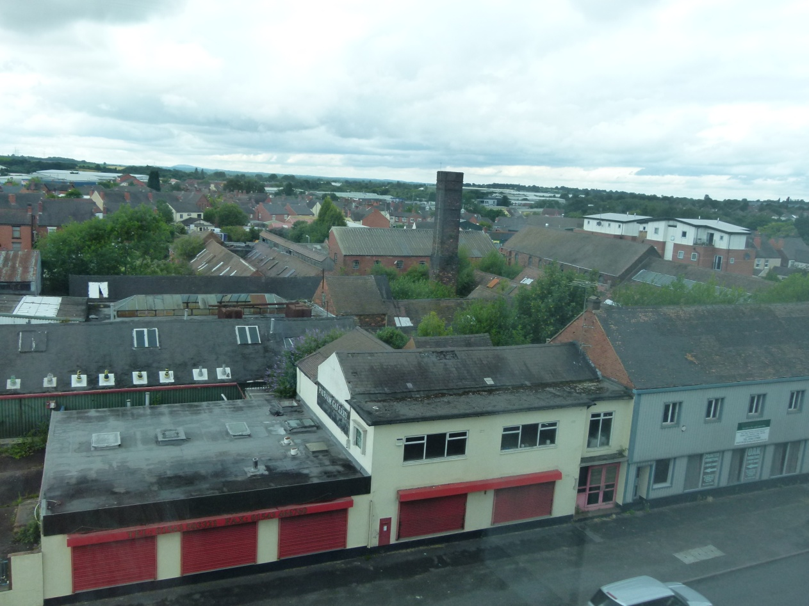

Monthly Meetings
We would like to draw your attention to the fact that, from November, all our monthly meetings will be held at Bethel Church again. We shall return to Wednesday morning meetings, starting at 10am.

9
FUND RAISING QUIZ
Here are the results and winner’s name for the recent place names quiz:

NO | QUESTIONS | ANSWERS
1 | Not an old place to sell merchandise | Newmarket
2 | Put underground Holy man at Crinkley Bottom | Bury St. Edmunds
3 | Complete bacon joint. | Fulham
4 | Young unmarried woman at the top | Maidenhead
5 | Speak to shallow river crossing | Telford
6 | Attach to, with nut | Bolton
7 | Get a little Xtra help here | Halifax
8 | Ernie’s other half | Morecambe
9 | Heavyweight toilet | Luton
10 | Holes in the ground | Wells
11 | Ancient fort? No | Newcastle
12 | We need it to breathe | Ayr
13 | Not in the west to murder the groom’s partner | East Kilbride
14 | Parent OK | Motherwell
15 | Swedish pop group with university official | Aberdeen
16 | Humorous 5 lined verse | Limerick
17 | Bill’s wooden stronghold | Fort William
18 | Head-piece for Miss Boleyn | Wigan
19 | Type of rifle | Winchester/Enfield
20 | Hop and jump with weight | Skipton
21 | Post-sleep by farmland | Wakefield
22 | Ice to water is not off, cutting the grass with a donkey’s cry | Melton Mowbray
23 | You can never find one when you need one. | Penn/Looe/Constable
24 | Timber in storage | Woodstock
25 | Almonds with Henry the car maker | Knutsford
26 | Price of a dog’s home | Kenilworth
27 | Transparent substance lies heavy with a summer fruit | Glastonbury
28 | Drag behind a cartoon cat | Felixstowe
29 | Wide steps | Broadstairs
30 | Hay house metal fastener | Barnstaple
31 | Cause of drips | Leek
32 | Whisky where two sides meet | Scotch Corner
33 | Chinese greeting to front garden entry | Harrogate
34 | Walk slowly along the edge | Ambleside
35 | Ancient burial place feels the heat | Barrow in Furness
36 | No tea party here | Boston
37 | Icy spring | Coldstream
38 | An arachnaphobic’s fear | Crawley
39 | 500 above | Dover
40 | Carry on consuming | Eton
41 | A ghost | Goole
42 | Entrance to an underground passage | Minehead
43 | Recently bottled | Newport
44 | Cheap rock | Penistone/Farthingstone
45 | Primary coloured vehicle | Redcar
46 | Continue tearing | Ripon
47 | A public schoolboy’s game | Rugby
48 | Scottish silver | Stirling
49 | A heavy river crossing | Tonbridge
50 | Not the soft heart of a candle | Hardwick

Thirteen quizzes were returned this year. There was one winner; Heather Morris from Great Wyrley who only had one wrong. She is donating her prize to a Methodist charity. She said she found it quite challenging.

11

` FORTHCOMING EVENTS
Date | Event | Venue | Time
Sunday  18 October  2015 | Annual Event and Exhibition | Bridgtown Social Club | 10.30 a.m. till 4.00 p.m.
Wednesday  18 November  2015 | “The man behind the name” (war memorial) by Paul Bedford | Bethel Church | 10.00 a.m. till noon.
Thursday  19 November  2015 | Coffee Day | Bethel Church | 2.00 p.m.  Till 4.00 p.m.
Wednesday  9 December  2015 | Christmas Celebrations | Bethel Church | 10.00 a.m. till noon.
Wednesday  20 January  2016 | “From footballer to vicar” by Peter Hart | Bethel Church | 10.00 a.m. till noon.
Wednesday  17 February  2016 | “New Street and Longford Road” by Bob Meek and Peter Bates | Bethel Church | 10.00 a.m. till noon.
Wednesday  16 March  2016 | “Wedges Mills” by Tony Bibb, Irene Sambrook and Sandra Alcott. | Bethel Church | 10.00 a.m. till noon.

Your opinion wanted
We have always held our monthly meetings in the mornings during the winter months and in the evenings during the summer months. Is that the way you like it, or would you prefer to have them in the mornings the whole year round? Tell one of our team which you would prefer.
12

HISTORY SOCIETY NEWS

Just in case there remains any confusion, here is a reminder that the role of Chairman is now being shared by three of us with the lead being taken as follows:
January to April: John Devey
May to August: David Battersby
September to December: David Williams
This year’s new book will be available at our Annual Event on 18th October. It is called “Bridgtown Bits and Bobs” and so we have decided to use this same title for the exhibition itself. Why is it called “Bits and Bobs”? All will be revealed shortly. The authors are John Devey and your editor. In it are lots of photographs that have not been published before. Many of these will be on show in the exhibition too. Did you know that you can purchase a copy of any photograph on show in the exhibition? You simply order it on the day and it will be forwarded to you as soon as possible afterwards.

All of “the team” are also still working on a longer-term project, the publication of a proper “History of Bridgtown” which will catalogue the growth and development of our village and include many stories from days gone by. It will probably take about two years before this enormous task is completed.

There are still a few copies of our Churchbridge book available. In addition our first book, Bridgtown Memories, has now been reprinted and is again available, together with all our previous publications.

We are still asking for World War 1 memorabilia for a display we are planning to mount at some relevant point in time. Please search your homes to see if you have anything that you can lend to us to commemorate the Great War. So far we have collected information but no pictures at all. Can you help?

13

LIFE IN 1930s BRIDGTOWN
In our last edition we started to publish extracts from the memories of Norman Seedhouse, son of Howard Seedhouse. Norman now lives in Norway but has sent us memories from his childhood. Here is the second extract from those memories.

Our Home
Beneath the house was a cellar. It was reached down brick steps behind the staircase door in the living room. Without any lighting, dark and cold, it was not a place I dared go into without company. At the near side with a candle or paraffin lamp, I could glimpse shelves lined with jars of homemade jams and preserves, other shelves with vegetables and groceries. At the far side lay the coal bunker filled from the trapdoor above opening into the street pavement outside. Between these two sides was a stone-flagged floor and along one wall a kind of stone and brick bench or platform, perhaps intended at one time as some kind of working surface. On one part of this stood a lidded pail filled with egg-glass, a kind of preserving liquid into which eggs could be immersed to be kept fresh. Here from time to time mother had a large brown wooden incubator, warmed by a small paraffin heater, into which she placed hen’s eggs for hatching. It was exciting to see the little yellow chicks pecking through their shells and then running around in the hatchery afterwards.

Groceries were bought at Summers’ shop in Hatherton Road. Mr Summers had been a great friend of father’s but died early: his widow and son remained fast friends. On my visits to the shop at this early age I was fascinated by the bacon slicer, hand worked of course, but even more exciting was being given a lift in Mrs Summers’ car, the only person we knew with a car apart from Grandad.

14

Work
Both sets of grandparents worked in the mines. Grandfather Seedhouse had been injured in some accident though still worked, but both he and his wife died within two weeks of each other when I was only two and so I have no memory of them. The double bereavement must have been a terrible blow for father. Grandfather Wright was a qualified mining engineer who had moved from place to place, including Bridgtown, as he sought promotion, and was now Under-manager, responsible for Underground work. His colliery was just across the fields from their new home in Great Wyrley. His house here was bought around 1932 and was intended to be his final move and for retirement.

Father had it impressed on him not to go down the mines, a hard and dangerous occupation. After he left school at age 14 therefore, he began work at Wootton’s Timber yard in Cannock, but at 17 he obtained his driving licence and moved to become a driver for Taylors Bakery in Blackfords where he was to remain for the rest of his life, apart from the years in the army. He rose early to pedal his ‘sit up and beg’ bicycle up to Blackfords, between Cannock and Hednesford. In the dark days of winter he had an acetylene lamp on the front, producing a light from a mixture of water and a white powder, fascinating me as I watched him prepare it. As there was no national health service at the time we were dependent on his employer for health assistance. We were then on the ‘Doctor’s List’, our doctor being Dr. Tomkinson, a fierce gruff man fearfully respected by his patients.

There will be more of Norman’s memories in our next edition. He has lots of fascinating and interesting things to say. Ed.

Frustration is trying to find your glasses
Without your glasses!

15

16
Adverts

Adverts help to pay for this magazine. We desperately need some new ones. This is important to the magazine’s future. Do you know someone who would like to advertise?
All charges are per annum and cover 4 editions of the magazine:
Full A5 page advert: £80 for a prepared advert.
£100 if we design the advert for you.
Half A5 page advert: £45 for a prepared advert.
£55 if we design it for you.
Quarter A5 page advert: £25 for a prepared advert.
£30 if we design it for you.
88888888888888888888888888888888888888

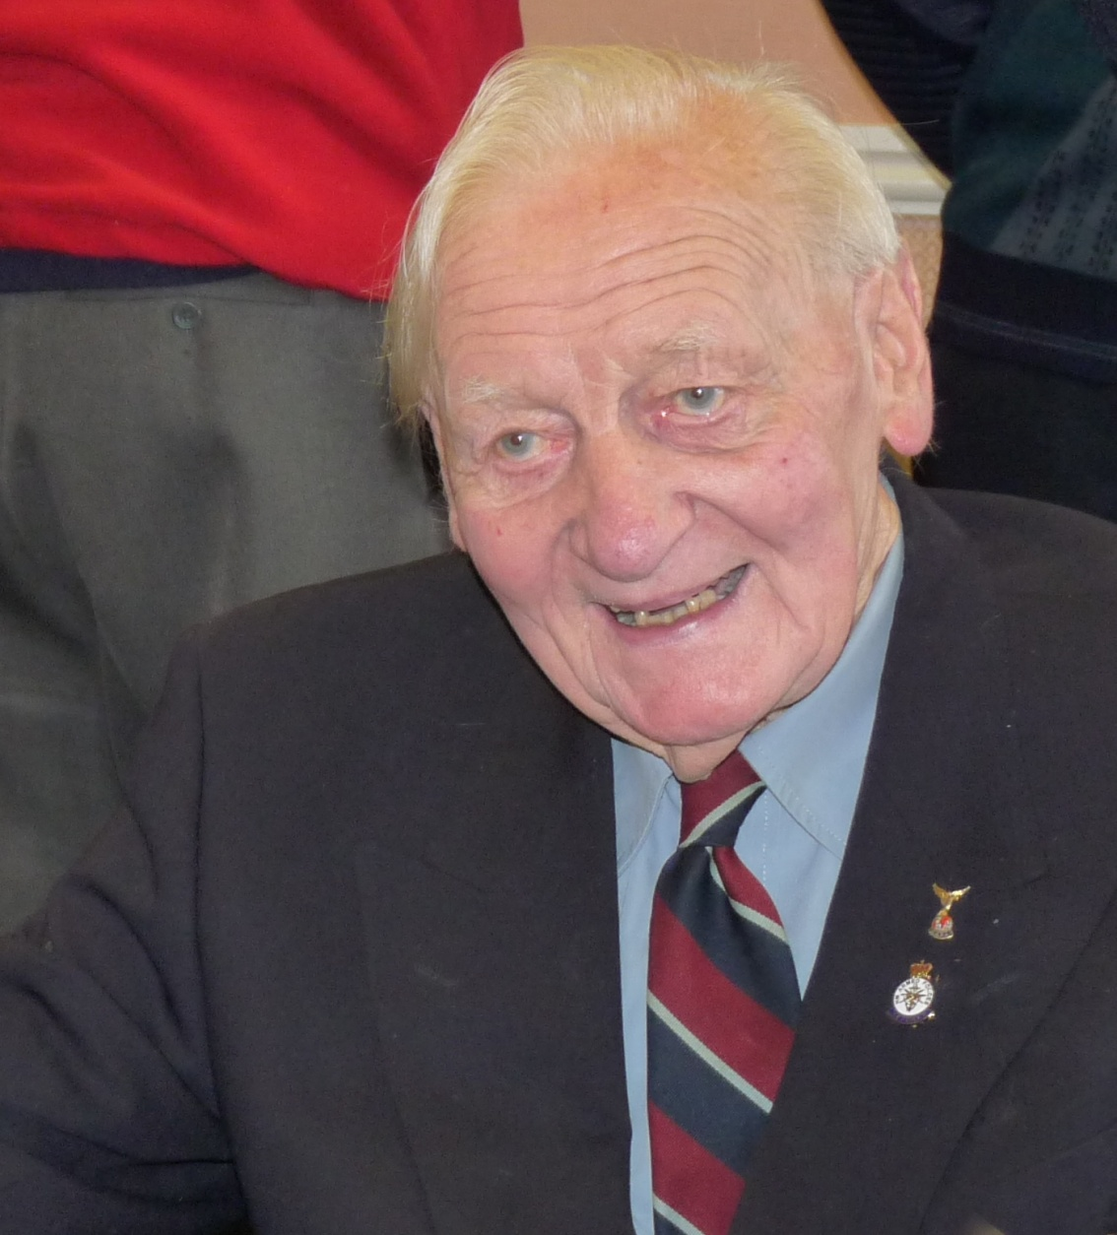
Fondly Remembered
It was with sadness that we learned of the recent death of Norman Summers. This picture was taken at our Annual Event in 2013. Our thoughts are with Carrie at this time. Perhaps one of our readers might like to write their memories of Norman to put in our next edition.

17

OBITUARY
DOUG WILLIAMS 1924 – 2015
Douglas Williams, who had been writing his memoirs, was a former regional president, lifetime vice-president and founder member of the Cannock Chase branch of the Royal Air Forces Association. He gave up the comparative security of a reserved occupation in 1942 to join the RAF as a leading aircraftsman flight mechanic – but not without a fight. As a 16-year-old sergeant in the local Air Training Corps squadron he was inspired by the spirit of pilots fighting the Battle of Britain and determined to join the RAF as soon as he was old enough.
He became an aircraft worker following an apprenticeship at Boulton Paul, Wolverhampton, as a way of improving his RAF prospects, believing that working as a riveter on Defiant aircraft at Wolverhampton and repairingthe wings of Hurricane aeroplanes at the shadow factory in Wallows Lane, Walsall, would guarantee acceptance when it came to enlisting.
But he miscalculated the value of his job to the war effort and it was only after a battle lasting several months and the intervention of his boss that the authorities relented and allowed him to enlist. His memoirs show he was known as ‘Duke Sahib’ during his three-year service in India.
After the war Mr Williams attended the inaugural meeting of the RAFA branch in Cannock in August 1946. For many years he masterminded the local Wings Week appeal, with the whole of his family involved collecting, opening tins and counting donations.
Paying tribute, fellow branch member Laurence McGowan said: “Doug was driven by having observed first-hand the need for a welfare organisation supporting former comrades and their families on return to civilian life. “His active concern for the lads continued into his late 80s when he was responsible for sending almost 100 parcels of goodies to squadrons in Afghanistan.” Mr Williams’ granddaughter Rebecca Cartwright said: “Granddad was very proud of his time in the RAF and the people he served with. “He was looking forward to the ceremonies that will mark the 75th anniversaries of the battle of Britain later this year.”
Courtesy of the Express and Star

Rita Hargreaves

Derrick Middleton has sent in a photograph to remind us all of Rita as we remember her in the years when she was living at no 19 Broad Street.
She is seen on the left with her husband John Titley ( who was killed in an accident at Littleton Colliery shortly after they were married). Also in the photo are her mother and father and her brother Ron, who now lives in Mid-Wales.
She ran the haulage business with her brother after the death of her father, but then sold up and moved to Bridgewater in Somerset to run a Cider Farm.
Derrick concludes with: “Although we have not seen much of her in the last few years, she leaves those of us who knew her with many happy and fond memories.”

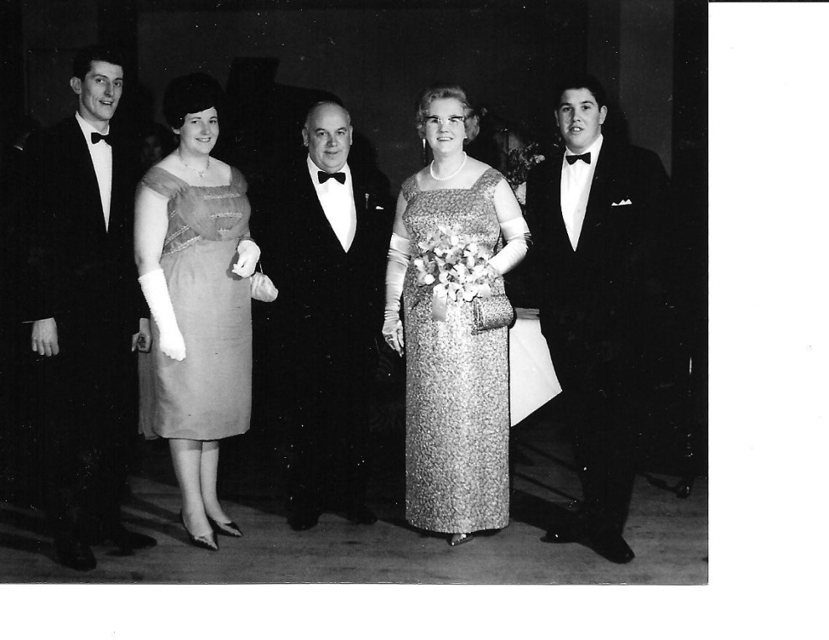
19
Tony Bibb remembers
COLIN GETHIN
On hearing of the passing of Colin earlier this year my memory took me to Bridgtown School on a midweek in the mid 1950s. The school football team were due to play an away game at Chadsmoor Secondary Modern School in Burns Street. I ran the line for school team games at that time and it was found that a member of the team had gone home at lunchtime feeling ill. So we were left a player short. No subs in those days! Our Sports Master, Laurie Wooliscroft, as usual supplied me with the return trip bus fares for all boys engaged and we travelled on the No 1, Walsall- Hednesford bus.
Mr Wooliscroft had searched all around the school for a likely replacement but there was no one available whom he wished to select. Having seen how keen 11 year Colin was for his football and, being a member of the Gethin family, well - he must be a good player- like his brothers! Mr. Wooliscroft considered it for a while and then went to speak to Colin in class to offer him a place in the team and clear his absence from school that afternoon with his form teacher. Colin of course was more than pleased to agree It was then appreciated that Colin did not have his football boots with him and I was swiftly despatched on a borrowed pedal cycle to the Gethin residence to request his mother to find out Colin’s boots in order for him to play in the game and to inform her he would be late home. This achieved it was a swift cycle ride back to school with the boots and, within 10 minutes, we all boarded the bus for Chadsmoor.
Sadly I recall we lost the game - one of our opposing players was Malcolm Beard, later to take up the game professionally and to play many seasons with Birmingham City. But Colin more than played his part in the match.
It was ten years or so later when I next saw Colin, when he joined his brother Len in the very successful Wedges Mills FC team playing in the Wolverhampton Sunday League. Colin and his brother Len became regular first choices in the team. It is sad when we lose family, friends and childhood acquaintances but so good to recall vivid memories of childhood and happier times.

20
NAME THE DOG

A few months ago we had a “Name the Dog” competition. He was won by Kath Stanton, who is a cousin of Michael Helps, so has Bridgtown connections
.

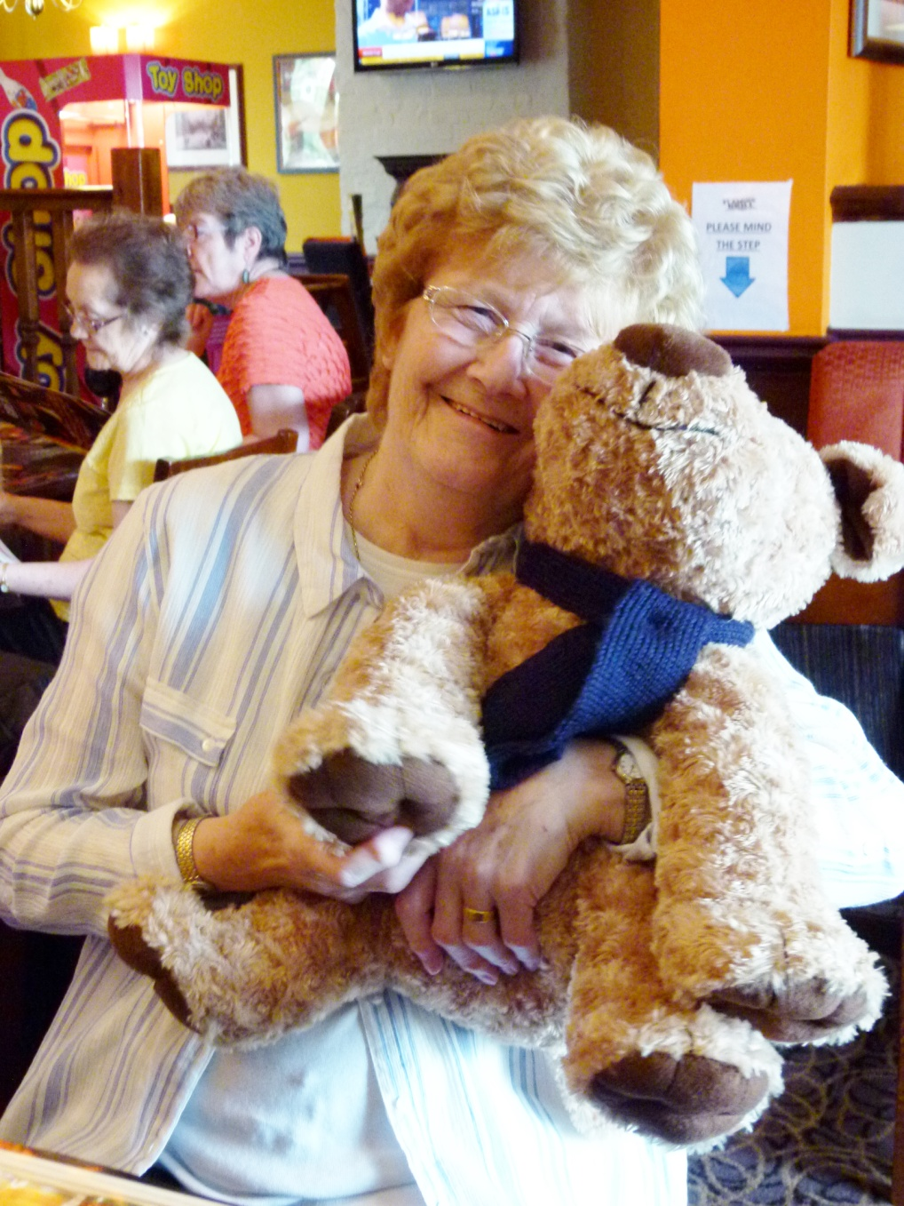

49 guesses were made in naming the dog but only one could get the right answer.

The dog’s name was TED.

(Don’t blame me! I only report the news Ed.)

21

BRIDGTOWN & DISTRICT LOCAL HISTORY SOCIETY
CHAIRMAN: Jan to April: John Devey
Tel: 01922 412008 Holly Lodge
3 Olde Hall Lane
Great Wyrley, WS6 6LL
May to August: David Battersby
Tel: 01543 503933 Three Trees
Wolverhampton Road
Cannock, WS11 1AS

Sept to Dec: David Williams
Tel: 01889 802534 Hazel Cottage
Main Road
Great Haywood, ST18 0SR
SOCIETY SECRETARY: Derrick Middleton
Tel: 01543 277268 18 Dorset Road
Heath Hayes
Cannock, WS12 2EF
TEAM SECRETARY: Sheila Jackson
Tel: 01543 577393 17 Pebble Mill Drive
Cannock, WS11 6UT
MEMBERSHIP SECRETARY: Bob Brevitt
Tel: 01922 414863 4 Windsor Road
Cheslyn Hay, WS6 7EN
TREASURER: John Devey (as above)

ARCHIVIST: Katherine Page
Tel: 01543 571386 3 Park View Court
Old Penkridge Road
Cannock, WS11 1H
MAGAZINE EDITOR: David Williams (as above)

OTHER TEAM MEMBERS: Tony Bibb, Tony Bullock, Bob Brevitt,
Jeanette& Barry Cartwright, Jean Dace,
Bob Leighton, Pat Evans,
Peggy Greenway,, Patrick Corfield

E-MAIL: bridgtownhistory@orangehome.co.uk

WEBSITE: http://www.bridgtownhistory.co.uk

22

