Chairman’s Comments

Since the creation of our Society in January 2009 we have had the privilege of using the excellent facilities provided at Bridgtown Community Centre, within the Ramada complex. The Community Centre was made available to the local community via the Parish Council by the courtesy and goodwill of a certain gentleman called Fred Pritchard who is, of course, our Society President.

Sadly, the recent sale of the Ramada complex has resulted in commercial decisions being made which have caused it to be necessary to cancel existing arrangements, withdraw Society assets, and immediately seek alternative premises. At the time of going to print it is not possible to relay any specific long term arrangements. However, suffice it to say that, in conjunction with the Parish Council, we are in numerous and serious discussions about future arrangements. Meantime, our good friends at Bethel Church have offered their facilities to the Society.

It is our intention to contact members as soon as more information becomes available. Inevitably the reality of being "open" to the commercial world will provide us with new challenges. However the Team are determined to ensure long term continuity of our current and increasing activities.

As an ardent Wolves supporter I believe that their Motto is aptly appropriate in our current situation. "OUT OF DARKNESS COMETH LIGHT"

The current programme of events will continue at Bethel Church in the short term although other venues may be used in the future. Please be aware of the possibility of changes in our arrangements.

See you at Bethel Church soon!!!!

Tony Pearson
2nd March 2014

3

Tony Bibb recalls.........................

THE WINTER OF 1947

Although I was only a 6 year old at the time I recall that winter very well.
There were endless hours of constant and heavy overnight and daytime snowfall. These were accompanied by raging blizzards which blocked roads, footpaths and house driveways. Outdoor toilets were frozen up as were road drains.
I remember that the main A460 Cannock - Wolverhampton Road was totally blocked on the unprotected stretch between Wedges Mills and the Hutments at Middle Hill and there was no public transport, no familiar No 21 green and yellow painted Wolverhampton Corporation Buses for almost 3 weeks. Snow drifted from across the open fields from Calf Heath direction and built up against the hedgerow on the opposite side of the road, completely covering the road surface.
Going anywhere at all was achieved with great difficulty and one of the aforementioned buses en route to Wolverhampton was forced to stop during the snow storms and evacuate its passengers on this stretch of road. The bus and roadway eventually became buried in several feet of snow and the hedgerows vanished from sight. After several days it became possible for villagers to walk up near to the stranded bus. The snow was so deep and packed that it came to just below the upper deck windows. Walking on several feet of packed snow one was able to peer into the top deck of the bus - the lower floor being totally enveloped by packed snow.. We walked well above the height of the hedgerows which indicated just how much packed snow there was. The Saredon Road from Middle Hill to Cheslyn Hay (known locally as the Bacon Pits) was also blocked for several weeks.
Prisoners of war, with their red arm bands, were eventually brought in to clear away the snow drifts with shovels, a massive feat on its own! After a considerable period of time the bus was recovered and the road opened again to regular traffic which in those days was spasmodic.
The whole episode had created quite an attraction and entertainment for locals. For many years afterwards fencing was erected by the Council every winter in the adjoining fields in an attempt to prevent another occurrence.

4
George and Derek Ralphs

In January the Society received a request from the family of George Ralphs for any information/photographs on his early life in Bridgtown. He was 90 years of age when he died so it was difficult to find anyone who knew him, but we were able to supply some photographs from his school days, when he attended the “Boys School”.

His younger brother Derek was also thrilled with the photographs as they contained some showing him in the school football and cricket teams. He remembers his days as a boy in the village as being very happy ones, and he sends best wishes to anyone who remembers him.

The family moved to Burton on Trent when they left the village, where they have lived for many years.

%%%%%%%%%%%%%

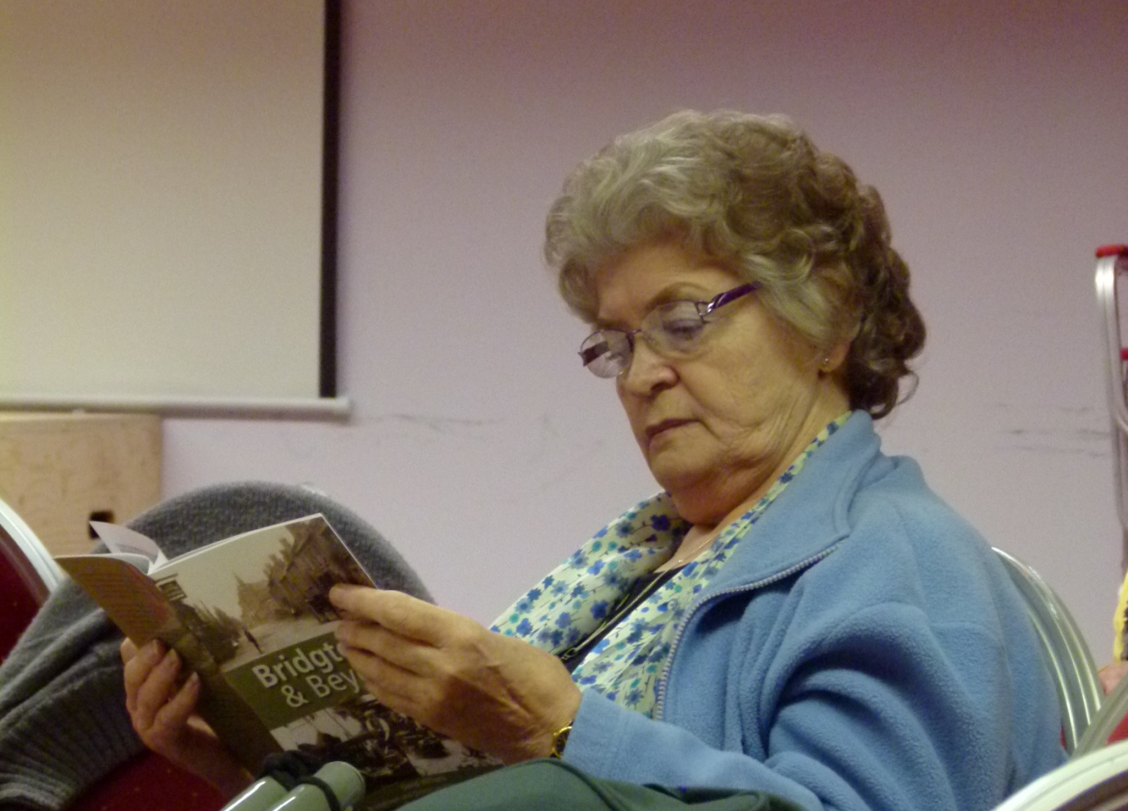

There are still copies of our latest book for sale. It is a good read as shown in this picture. Elsie Harvey seems to be really engrossed in reading it. Do you know anyone who would like to buy a copy?

5
How Our Society Started

Here we continue the article written a number of years ago by our chairman Tony Pearson. It was sent to Professor Carl Chinn and part of it was published in the Express & Star in September 2007. We are now reading the parts of Tony’s article that have never before been published.

88888888888888888888888888888888888888

“The Hole in the Hedge” by Tony Pearson

Memories and Reflections of a Bridgtown Boy

My fifteenth birthday in 1949 was a real highlight. I had persuaded, probably coerced, my parents of the absolute necessity to have my own bicycle. I believed that I was now sufficiently mature, educated and eloquent enough to provide an economic case so that I could offset increasing travel costs. I vividly recall going with my father to Jellyman’s Cycle Shop in Walsall Road. I soon spotted a “Raleigh Lenton” with dropped handlebars. It was bright green and I was smitten. My Dad was now aged 67 years and circumstances were such that he had to continue working to ensure a reasonable standard of living for our family. He signed a Hire Purchase agreement promising to pay two shillings and sixpence every week for three years. I often think back with a lump in my throat to the many sacrifices that my parents made for me. Truth was that, at the time, everything just washed over my head! Realistically my bike was the biggest and best material possession in my life.

I was now enabled to be more independent and adventurous. I could join with old and new friends who had a similar outlook. In the summer months we ventured into new territories such as Sutton Park, Boscobel, Walsall Arboretum, Milford, etc., but come winter I settled down to the friendships around my growing involvement with the Youth Club and its associated activities. I genuinely had found a place of both comfort and challenge, a must for any healthy ambitious teenager. On the subject of challenge I went through a period of positive guilt.

Leaving school and starting one’s first job is a jolt in everyone’s life. I was no exception. In reality, I had no positive idea of what I wanted to do or was capable of doing. In September 1950 I found myself working for the local Railway Company, in those days known as L.M.S. (London, Midland & Scottish) in their Walsall Goods Office.

6

To say that the office was Dickensian is an understatement! We all had quill pens, upright desks and stools. I was very much the Junior, in effect the “dog’s body” and, to make it worse, work commenced at 7 a.m. From my home in Bridgtown I would run to Cheslyn Hay railway station to catch the 6.35 a.m. train and, as the winter set in, the dark cold mornings convinced me that this was not the job for me!

In January 1951 I found a job working with a firm of accountants in Waterloo Road, Wolverhampton. The job itself was interesting with the possibility of signing articles for a career as an accountant. There was another genuine upside in that I worked within spitting distance of Molineux and often saw my heroes around the ground. The downside was that my salary was twelve shillings and sixpence per week, yes just sixty two and a half pence in today’s money! The miniscule payment encouraged me to abandon the normal bus service and to go to work on my bicycle. Believe me or not, I frequently would cycle home for lunch and, of course, return to Wolverhampton within the 75 minute lunch break. I believe that around this time there was a cycling champion by the name of Reg Harris. Well, I was so fit that I could have given him a race anytime!

By now cinemas were open again on Sundays and, together with my Youth Club friends, we would check up who would be preaching at the Sunday Evening Service. If the consensus was that the preacher would be boring we would head for the cinema instead.

Society in general was still recovering from the aftermath of war, but somehow there was a distinct feeling that our generation was vitally important in the search for positive change in our country. Competition and involvement were encouraged in all directions, be it sport, drama, music, or even public speaking.

zzzzzzzzz

Tony’s article is not only a wonderful personal record of his early life but is a compelling Social History account. We look forward to reading the final part of his story in our next edition. Ed.

 Law of Gravity - Any tool, nut, bolt, screw, when dropped, will roll to the least accessible place in the universe.
 Law of Mechanical Repair - After your hands become coated with grease, your nose will begin to itch and you'll have to visit the toilet.
7

8

Years Ago: Saturday Afternoons

The scene is Cliff’s Corner, late on a Saturday afternoon during the months from August through to May.

The time is just after 5pm and a crowd begins to gather. The crowd begins to form into a queue and everyone tries to be near the front of the queue or they may be disappointed.

At around 5.45 p.m. a van appears and its arrival is greeted with a cheer. A man jumps out with a pile of papers that he is delivering. They are copies of the “Sporting Star” printed on its familiar pink paper. A big cheer then rings out from the expectant crowd.

He takes the papers into Cliff’s shop and everyone rushes into the shop to purchase their copy.

A short time after the Sporting Star was delivered another van appears. This one is delivering the “Sporting Argus”, the Birmingham based sports paper, also printed on pink paper.

For most people in the crowd this is the send-best paper but latecomers usually have to settle for it because the others have all gone.

For most members of the crowd the routine would be take home the paper and check the results against their Pools Coupons to see if all their dreams have come true. This would then be followed by an avid reading of the report detailing how their favourite team had played that day.

How different is all this from today when the progress of every football match can be followed on TV or the radio or numerous other technological devices! Somehow it was all a lot more exciting in those days!

 Law of Probability - The probability of being watched is directly proportional to the stupidity of your act.
 Law of Random Numbers - If you dial a wrong number, you never get a busy signal; someone always answers.
9
John Devey has compiled a crossword so that you can exercise your brains. Some of the clues have Bridgtown connections.
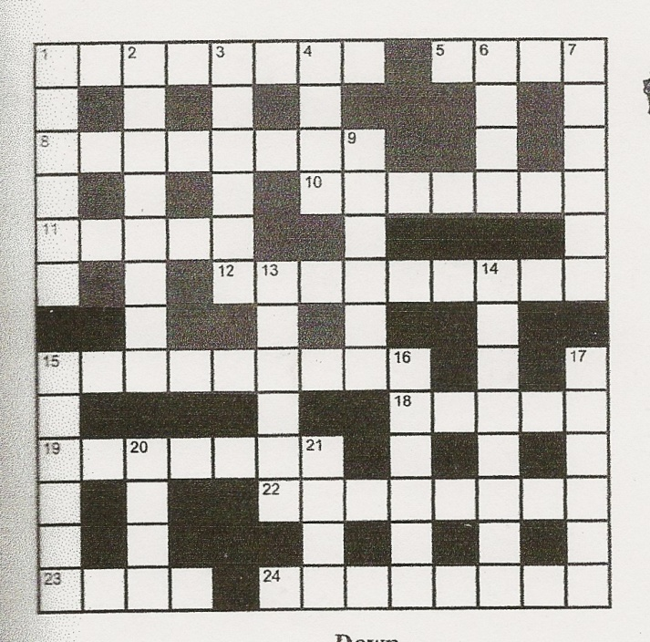

CLUES ACROSS

- “Y” shaped stick, elastic and pebbles. (8)
- School in Church Street named after this Saint (4)
8 Is this the opposite of quicksand? (8)
- Best estimates (7)
- Ordinary people (5)
- Local name for our own Regiment (9)
- Bronze Age stone rows seen here (9)
18 Compass point of our main thoroughfare (5)
19 Old Testament Book (7)
22 Vote for (8)
23 Oxen’s heavy burden (4)
24 Small, spiny and nocturnal, or a trademark (8)

10

CLUES DOWN

1 Local pub (6)
2 Sly liaisons on the side (3, 5)
3 The Cornish make them (6)
4 With a river crossing it could be a local Lane (4)
6 Pretends to be someone else (4)
7 Gaps in concentration (6)
9 Bag or coat? (6)
13 One of the old local pubs (6)
14 Rebuke (8)
15 Colloquially, Cannock Agricultural, with 20 down (6, 4)
16 Not starting (6)
17 Before the chicken (3, 3)
20 See 15 down
21 One and only, or a fish (4)

+++++++++++++++++++++++++++++++++++++++++++++++++++++++++
Derrick Middleton remembers..............

The Return of a Hero

One of my early memories was when a substantial number of residents of Bridgtown gathered to walk up the New Road on a dark night during 1945, to meet a train at Cheslyn Hay Railway Station. Most of the children (including myself) had jam jars, with a candle inside, tied to a stick to light the way. The train was bringing home Bill Pearson who had been a P. O.W. in Crete for four years. On arrival the crowd quickly filled the small platform, and as Bill opened the carriage door a big cheer went up. After the family greetings were completed, he was lifted shoulder high, for the walk back to the village; the adults sang cheeky songs about the German leaders (much to the delight of us children).

The hero was delivered to his home in the bungalows on the Watling Street and left to spend time with his family. Bill returned to his job at Hawkins Tiles, played football for Hednesford Town (where he is still remembered with great respect) and cricket for Hawkins.

He died in 2012 but will be remembered as a true Bridgtonian and a real local hero.
11

Bridgtown & District Local History Society

` FORTHCOMING EVENTS
(Revised Programme)

Date | Event | Venue | Time
Thursday 13th March 2014 | Coffee Day | Bethel Church | 2.00 p.m. till 4.00 p.m.
Sunday 16th March 2014 | Heritage Service | Bethel Church | 6.00 p.m. till 7.00 p.m.
Wednesday 19th March 2014 | “My Life Story” by Kay Matthews. | Bethel Church | 10.00 a.m. till noon.
Wednesday 16th April 2014 | “Upstairs Downstairs” by Patricia Boyd.  (Return by request) | Bethel Church | 10.00 a.m. till noon.
Wednesday  21st May 2014 | “Local Lad in the Police Force”  Patrick Corfield | Bridgtown School Hall | 7.00 p.m.  till 9.00 p.m.
Wednesday  18th June 2014 | To be confirmed | Bridgtown  School Hall | 7.00 p.m.  till 9.00 p.m.
 | Details of meetings for the rest of the year will be available shortly, when relevant venues will also be announced.

Bridgtown & District Local History Society
xxxxxxxxxxxxxxxxxxxxxxxxxxxxxxxxxxxxxxxxxxxxxxxxxxxxxxxxxxxxxxx

 Variation Law - If you change lines (or traffic lanes), the one you were in will always move faster than the one you are in now.
 Law of the Bath- When the body is fully immersed in water, the telephone rings.
12

HISTORY SOCIETY NEWS
The biggest news currently is the fact that Bridgtown Community Centre has had to close its doors permanently. This was a sudden decision that had to be taken by the Centre Trustees. The new owners required a commercial rent for the use of the property whereas previously it had been subsidised by Fred Pritchard. This has meant that the society has had to change the venue for all of our monthly meetings. The next two morning meetings are at Bethel Church and the next two evening meetings are to be held in the School Hall. (See programme opposite). Soon we shall be able to announce plans and venues for the rest of 2014.
Negotiations are going on with the Parish Council and a third party about acquiring a different property that would meet all the needs of our Society. It is necessary to keep the details of this secret at the moment due to confidentiality issues. Once we have something definite to announce we will inform members accordingly.
At our February meeting our chairman Tony Pearson explained to members why it is so important that the society needs to raise money in order to fulfil its continued development. This is even more important now that we have lost the use of the Community Centre.
It is necessary to remind members that subscriptions for the forthcoming year become due on 1st April. The family subscription price for 2014/2015 is £7.00. Each subscription brings with it the 4 editions of this magazine for free. Each magazine retails for £1.50 to non-members.
World War 1 memorabilia is needed for a display we are planning to mount at some relevant point in time. Please search your homes to see if you have anything that you can lend to us commemorate the Great War.

We still have lots of copies of Bygone Bridgtown and Bridgtown Born & Bred and Bridgtown and Beyond for sale. Every time we sell one of these books it is another £5.00 towards our fund raising. Do you know somebody who would like copies of any of them?

Plans are well underway for the publication of this year’s new book which will concentrate on the Churchbridge area. Do you have any relevant photographs that you could lend us to copy?

13

Irene Sambrook is one of our members who now lives in Stone. She has provided us with an account of her father’s life, written by himself. Irene is the daughter of Olive Harris (nee Smallman). The Smallman family kept the Fish & Chip shop in New Street years ago. Irene’s Dad didn’t come from this area originally but his story is well worth reading as it is a poignant reminder of times gone by. Eventually Irene grew up in Wedges Mills.

Here is Part Two of this fascinating article:

The Story of William Harris
In his own words.

The first radio I ever heard was made by a neighbour of ours. We had had crystal sets with earphones but were amazed to hear transmissions straight from a speaker. The power source was wet batteries called accumulators which had to be charged up at local garages or shops. It would last about a week or so before it needed recharging, so everyone had two accumulators, one in use and one on charge.
At school one of the teachers told us that he had information that, one day in the future, we would buy a machine in a box which we would plug into our radio so that we could receive pictures at the same time.
Cars were very few at that time and a road was only considered to be a major road if it was at least twenty feet wide. Lorries were mainly driven by steam engines and had solid tyres. They would have a driver and a stoker like a railway engine. By the roadside you would often see piles of ash where the fires had been raked. I lived in Brereton and we had only one bus a day. It was a Midland Red bus on its way to Lichfield, and that had solid tyres too. It was only seven miles to Lichfield and most people would walk it there without question. Such was poverty in those days.
Groups of unemployed men would often be seen playing Pitch & Toss. The degradation of those days cannot be imagined now. I can remember my Dad taking up some floorboards in order to retrieve a sixpenny piece that had been accidentally dropped! That sixpence meant that the next meal was assured.
14
Things did start to improve for our family about 1932 when my Dad got employment as a salesman with the Singer Sewing Machine Company. He lifted us out of the doldrums and into a better standard of living. In time he bought a little car, an Austin Seven, and I could drive that car when I was twelve years old. The mechanics of it were so simple in comparison to today’s autos. He only paid £25 for it and it was used for carrying sewing machines for years afterwards.
My eldest sister Brenda was four years older than me and, like all working class girls, was sent out into service as a lackey to the richer and more fortunate. At the tender age of fourteen she had to be up to clean and light fires at six o’ clock in the morning and would still be working as late as eight o’ clock in the evening. All this for a wage of four shillings a week and her keep. She would have one half day off each week but I don’t think she ever complained.
Next in line was my brother Jim, who was two years older than me. He took after our Dad and was an athlete of some repute. He played football for his school and was a schoolboy international player. At sixteen he was placed on the books of Aston Villa but was killed in an accident on the docks in Liverpool before he could realise his ambition to play professional football. His death was a great shock to our happy family and, for the first time, brought us children to face reality. Death was something that had never entered our thoughts before. My Dad had had a shock of black hair but, on being told of his death, by the next day it had turned white. He never really recovered for the rest of his life. From then on his eyesight deteriorated and, later in life, he became registered as blind. I could never bring myself to tell my parents that I had seen a vision of Jim’s death distinctly for two nights prior to it happening. I had just passed it off as being a nightmare and, when it actually happened, my mind went completely blank for about half an hour.
I had an interview for employment with Jim’s boss at the garage where he worked and had a 30 minute walk to get there from home. He was killed at about 3.30 p.m. in the afternoon and that was exactly the time I had set out on my walk. I cannot remember anything at all about that walk as my mind was completely blank for the whole period. When I arrived at that office I sat in the waiting room and, it was while I was there, that the news of my brother’s death came through on the telephone. I actually witnessed a shocked director take the call. I think that there must be a close relationship between certain children that is not yet understood. I have heard about such occurrences on many occasions since and have been tempted to tell my story, but I never have until now.
The last part of William Harris’s story will appear in the next edition. Ed.

15

Adverts in our magazine

We could do with a few extra adverts in our magazine. This is important because it helps to meet our expenses. Do you know someone who would like to advertise?

All charges are per annum and cover 4 editions of the magazine:
Full A5 page advert: £80 for a prepared advert.
£100 if we design the advert for you.
Half A5 page advert: £45 for a prepared advert.
£55 if we design it for you.
Quarter A5 page advert: £25 for a prepared advert.
£30 if we design it for you.

@@@@@@@@@@@@@@@@@@@@@@
16

I’m Very Well Thank You

There is nothing the matter with me,
I’m as healthy as I can be.
I have arthritis in both of my knees
And when I talk – I talk with a wheeze!
My pulse is weak and my blood is thin
But – I’m awfully well for the shape I’m in!

Arch supports I have for my feet
Or I wouldn’t be able to be out in the street.
Sleep is denied me night after night
But every morning I find I’m alright.
My memory is failing, my head’s in a spin
But I’m awfully well for the shape I’m in.

The moral is this – as my tale I unfold,
That for you and me who are getting old,
It’s better to say “I’m fine” with a grin
Than to let folks know the shape we are in.
How do I know that my youth is all spent?
Well, my “get up and go” has got up and went.

But I really don’t mind when I think with a grin
Of all the grand places my “got up” has bin!
Old age is golden I’ve heard it said
But sometimes I wonder as I get into bed,
With my ears in a drawer, my teeth in a cup,
My ‘specs on the table until I get up.

‘Ere sleep overtakes me I say to myself
“Is there anything else I could lay on the shelf?
When I was young my slippers were red,
I could kick my heels right over my head.
When I was older my slippers were blue
But I could still dance the whole night through.

Now I am old my slippers are black.
I walk to the shops and puff my way back.
I get up each morning and dust off my wits
And pick up the paper to read the obit’s.
If my name is missing I know I’m not dead
And so I have breakfast and – go back to bed!
Author unknown

17
Nearly 85 Years Ago: An Advert from the Local Press

BRIDGTOWN HOSPITAL CARNIVAL
September 1st to September 7th 1929

PROGRAMME FOR THE WEEK

SUNDAY SEPT 1st: GREAT CONCERT arranged by the “Express and
Star” in the UNITED METHODIST SCHOOLROOM at 8 p.m.

MONDAY – CARNIVAL DANCE at the QUEEN’S HALL, CANNOCK
8 p.m. to 2 a.m.

TUESDAY – BAND CONCERT

WEDNESDAY—CHILDREN’S SPORTS at Recreation Ground,
commencing at 5 p.m.

THURSDAY – CHILDREN’S CHOIR COMPETITIONS at the
Recreation Grounds.
Entries close on August 24th. Judges Messrs. J. Yates and L.C.Hawkins
Syllabus Price 3d. post free. Entry forms from Mr. W.H.Whitehouse, Jun, “Clonakeagh”, Bridgtown. Entrance fee 2/6 including admission to ground.
Prizes: 1st Silver Challenge Cup and £2; 2nd £1; 3rd 10/-

FRIDAY – WINDOW DRESSING COMPETITION and GORDON
BULLOCK’S CONCERT PARTY

SATURDAY -- GRAND FINALE PROCESSION. Great MOTOR
CYCLE RODEO by Burntwood Motor Cycle Club. Bridgtown
Allottees’ Show at Recreation Ground. Entries to Mr. G. Lunt, 52 Broad
Street, Bridgtown. COMMUNITY SINGING 3 p.m., conducted by
A, Whitehouse, Esq., J.P.

You cannot afford to miss these events!

COME AND ENJOY YOURSELVES

W. H. WHITEHOUSE, Chairman

18

Peter Bates remembers..........

BRIDGTOWN COBBLER

The Davis family used to live in Park Street and many people used to visit the shed on their property for a very good reason.

Howard Davis Senior was a fine shoe and boot repairer. He could also make you a pair of shoes or boots. As well as making shoes or repairing shoes he also made all of his own shoe-repairing-machinery out of disused items like old mangles. In his spare time he made model steam trains, using pin heads as rivets.

Howard’s wife Mary was my mother’s step-sister. She was one of seven children and was a lovely lady.

Their son, also Howard, became an international violinist. It was me who bought him his very first violin from Cannock Market for around £1. It had no strings. These were bought from Charlie Beesley’s Music Shop in North Street.

I remember that their daughter, also Mary, used to paint miniature silhouettes in black and white. They were something special.

What a talented family they were!

ooooooooooooooooooooooooooooooooooooooooooooooooooooooooooooooo

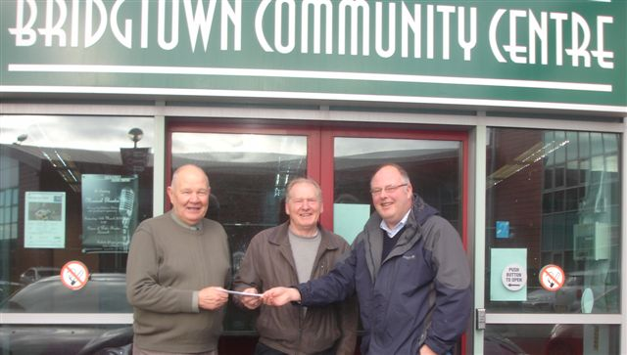
Barry Cartwright, property steward at Bethel Church, receives a cheque from Eddie Smith and John Kraujalis on behalf of the Bridgtown Community Trust for repair work to Church Buildings

19

“The Bridgtonian”

Our magazine is called “The Bridgtonian” after the school magazine for Bridgtown Boys’ School in the 1930s and 1940s. In previous editions we have reproduced a wide variety of articles from those magazines. This time we look back at the third ever edition, written in Summer 1932. Three extracts are included..

$$$$$$$$$$$$$$$$$$$$$$$$$$$$$$

First, The Staff

Headmaster Mr. J. Croft, B.Sc.
Class VII Mr. H. A. Boot
Class VI Mr. W. E. Simpson
Class V Mr. F. E. Hindley
Class IV Mr. A. Holt
Class III Mr. W. Jones
Class II Mr. W. G. Farmer

Prefects: J. Field, G. Ponton, F. Wright, R. Linley, J. Howdle.

Magazine Editors: James Field and W.E. Simpson
xxxxxxxxxxxxxxxxx

Secondly, An Event

A Memorable Event in My Life

It was a beautiful sunny afternoon during my summer holidays last year, when this adventure befell me. I was walking slowly along the side of the canal at Leacroft with my dog Jip, when suddenly I heard a great splash.

Looking behind I was just in time to see a small boy fall into the water. By the way he was struggling I could tell he was near to drowning. Rushing to the spot where he had fallen in I flung off my jacket and dived into the water. I reached his side just as he was going down for the second time. Putting my arm around his waist I made for the bank.
20

When I had safely brought him to the side I began to swing his arms about to bring him back to consciousness, for he had fallen into a faint. After he had come to, I asked him his name, which he said was Joe Brown. Then I asked him how it happened. He said he was walking along the tow-path when he saw a fish in the water. So he tried to catch it but slipped and fell in.

After he had told me his story he asked me if I would accompany him home to which I consented. So we began to go back the way we had come. Soon we reached the main road and, walking along, we met the lad’s mother who was very pleased to see her son safe though wet.

I was about to leave them when the lady asked me to have tea with them. I said I was unable because I had made other arrangements with a friend. However, as the lady still begged of me to go with them, at last, out of courtesy, I consented to go.

L. Withington, VI
xxxxxxxxxxxxxxxxxxxxxx

Thirdly, An activity

My Hobby

My hobby is making different kinds of toy ships. I am now making a ship on which to put some divers. The divers are made out of pegs weighted with lead. I made a little hook out of some brass wire and tied some cotton on to it, and pretended that it was a crane hanging from an aeroplane. With the hook we fix it on to one of the tin boats and make the tin boat sink. We pretend that the tin boat is a sunken submarine, then we get the hook and pretend that we are dredging for it. My boy friend and I made a diving bell out of a part of a gas bracket. Getting a ruler we pretended that every inch was a fathom. We tied the bell to a piece of cotton and kept on letting it drop into the water. My big ship had a bulb fixed to the front so we covered it so far over with rubber. I am calling her the St. George. We have fastened St. George’s flag on her mast with a needle.
R. Lewis, V

21

BRIDGTOWN & DISTRICT LOCAL HISTORY SOCIETY

CHAIRMAN: Tony Pearson
Tel: 01543 255235 3 Copperfields
Lichfield, WS14 9YQ

VICE CHAIRMAN: David Battersby
Tel: 01543 503933 Three Trees
102 Wolverhampton Road
Cannock, WS11 1AS

SECRETARY: Derrick Middleton
Tel: 01543 277268 18 Dorset Road
Heath Hayes
Cannock, WS12 2EF

MEMBERSHIP: Bob Brevitt
Tel: 01922 414863 4 Windsor Road
Cheslyn Hay, WS6 7EN

TREASURER: Sheila Jackson
Tel: 01543 577393 17 Pebble Mill Drive
Cannock, WS11 6UT

ARCHIVIST: Katherine Page
Tel: 01543 571386 3 Park View Court
Old Penkridge Road
Cannock, WS11 1H

MAGAZINE EDITOR: David Williams
Tel: 01543 571500 51 Allport Road
Cannock, WS11 1DY

OTHER TEAM MEMBERS: Tony Bibb, Tony Bullock,
Jeanette& Barry Cartwright,
Jean Dace, John Devey,
Pat Evans, Peggy Greenway,
Michael Helps, Bob Leighton, Bob Brevitt, Patrick Corfield

E-MAIL: bridgtownhistory@orangehome.co.uk

WEBSITE: http://www.bridgtownhistory.co.uk

22

